PETROL COKE - Specifications
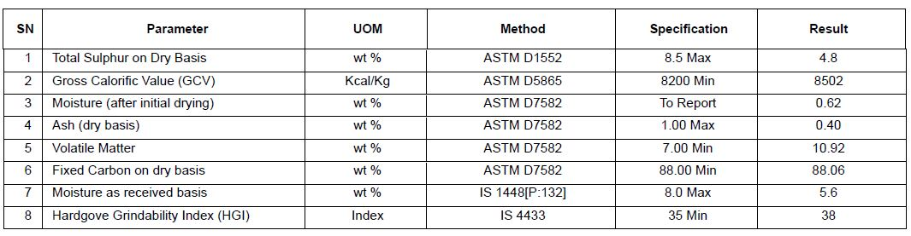

Fuel Grade Raw Petrol Coke
(Low Sulphur)

Specification  Sl No | Parameter |  | Unit |  | Value
1 | Moisture content (As received) |  | % Mass |  | 8 max
2 | Ash ( ADB ) |  | % Mass |  | 1 max
3 | Volatile Matter  ( ADB ) |  | % Mass |  | 8 min
4 | Fixed Carbon (Calculated) |  | % Mass |  | 87 min
5 | Total Sulphur  ( ADB ) |  | % Mass |  | 3.5 to 5 max
6 |  | Hargrove Grindability Index (HGI) |  | 35-60 min.
7 | Gross Calorific Value (GCV)( ADB ) |  | Kcal/Kg |  | 8200 min

